RESOLUTION NO.__________

RE: CERTIFICATE OF APPROPRIATENESS UNDER THE
PROVISIONS OF THE ACT OF THE PENNSYLVANIA
LEGISLATURE 1961, JUNE 13, P.L. 282 (53
SECTION 8004) AND BETHLEHEM ORDINANCE NO.
3952 AS AMENDED.

WHEREAS, it is proposed to replace old shingles with GAF Slateline shingles at 222 E. Market St.

NOW, THEREFORE, BE IT RESOLVED by the Council of the City of Bethlehem that a Certificate of Appropriateness is hereby granted for the proposal.

Sponsored by: (s)

(s)

ADOPTED BY COUNCIL THIS DAY OF

(s)
President of Council

ATTEST:

(s)
City Clerk

HISTORICAL & ARCHITECTURAL REVIEW BOARD

The applicant proposes to remove the existing shingle and replace with GAF Slateline shingles at 222 E. Market St.
APPLICATION #1:

Joe & Lea Iorio
77 W. Broad St., Ste. 1, Bethlehem, PA 18018

OWNER:

__________________________________________________________________________

The Board upon motion by Phil Roeder and seconded by Marsha Fritz adopted the proposal that City Council issue a Certificate of Appropriateness for the following:

- Remove existing shingles and replace with GAF Slateline shingles.

- Color of shingles to be Antique Gray.

3. To reuse the metal trim and flashing where possible.

4. The ridge cap will remain Red and the counter flashings will be Black with
matching sealant.

5. The motion was unanimously approved.

__________________________________________________________________________

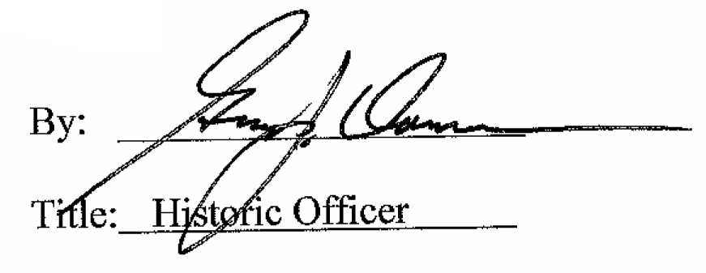

Date of Meeting: August 5, 2015

